Supplementary File 1. Overview, actors claims, objectives and values Abdissenbosch

 | Actor | Claim | Objectives | Landscape Values
Politics | College of the municipality of Landgraaf | Wind turbines in Landgraaf, on condition of the RAK, social support, benefits for residents and protection of nature | Develop energy parks to achieve region's ambition of being energy neutral by 2040 (PALET) reach the national Climate Agreement (via RES) | Climate
 |  | Solar parks in Landgraaf, on condition of the RAK, social support, benefits for residents and protection of nature
 | Bundeswehr | No windturbine at Kreupelbusch above 90 m for safety | Protect empty horizons so that the Awacs planes landing and taking off from the army base at Geilenkirchen are not hindered | Well-being
 | Parties GBBL, CDA, LWH, VVD, OPL, Progressieven | No wind turbines in Landgraaf, voted in council meeting | - Listen to citizens requests  - Protect public health  - Conserve the environment | - Well-being  - Biological
 | Party SP |  | Develop wind turbines and solar parks only on condition of clear support and benefits without sacrificing nature | Biological
 |  | No solar park at Kreupelbusch, voted in council meeting due to unclear support of and benefits for citizens (but in favour)
 | Province Limburg | Solar parks outside exclusion areas POL14 and concept Zoning Vision and in preferred areas' POL14 | Develop wind turbines & solar panels to achieve region's RES targets and ambition for reaching the national Climate Agreement (on condition of protecting Natura 2000 and NNN) | Climate
 |  | Windturbines outside exclusion areas POL14, and concept 'omgevingsvisie' and preferably in 'voorkeursgebieden' POL14
 |  | Kreupelbusch as part of Heidenatuurpark, with ecoduct across the Europaweg-Noord, between the Brunssummerheide and the Tevenerheide | Create a robust international ecological connection so that plants and animals can  spread again | - Biological  - Ecological
Planet
 | Natuur  monumenten |  |  | - Ecological  - Biological
 | IKL | Investments should be made in the natural values of the area | - Create diverse environment  - Better habitat for species  - Development of nature and conservation | - Ecological  - Biological
 | NMF Limburg | Kreupelbusch as exclusion zone for wind and solar parks in the 'zonnevisie' due to Gold-Green nature label within NNN | - Preserve valuable nature and protect plant/animal species  - Energy development not at the expense of the landscape, else compensation | - Ecological  - Biological
 | Resident of Abdissenbosch: Burger | Kreupelbusch is Gold-Green nature zone (NNN) and part of Heìdenatuurpark so energy development should be excluded | - Prevent degradation of nature  - Maintain ecological link between the two internationally protected Natura 2000 areas Brunssummerheide and Tevenerheide | - Ecological  - Biological
 | Initiator and landowner Bodemzorg | Solar park at Kreupelbusch, on condition of ground protection and profitable business case | Repurpose closed landfill sites to a socially responsible function with the aim to:  - prevent negative effects on surroundings  - invest in the natural values of the area  - support sustainability policies | - Biological,  - Well-being  - Economic
Profit |  | Wind turbines at Kreupelbusch on outskirts next to border
 | Developer Unisun Energy | Solar park with 30.000 panels at Kreupelbusch, generating 12,5 megawatts | Build solar park to provide clean and sustainable energy solutions and achieve revenue | Economic
 | Developer NPG Energy / Enovos | 3-4 wind turbines at Kreupelbusch on outskirts next to border | Build wind park to contribute to sustainable growth of industrial zones | Economic
People | Residents of Abdissenbosch | No wind turbines because of horizon pollution, impact shadow and noise pollution | - Keep empty horizons  - Preserve attractive scenery  - Prevent health hazards and disturbance | - Aesthetic  - Well-being
 | Advisory group Abdissenbosch | Solar park on condition of nature conservation and enhancement of area | - Preserve and upgrade existing natural values and biotopes of the area  - Keep the area accessible to everyone  - Educate walkers and children about flora/ fauna | - Biological  - Ecological  - Recreation  - Learning
Supplementary File 2. Overview of actor claims, objectives and values Akerweg

 | Actor | Claim | Objectives | Landscape Values
Politics | Province Limburg | Solar parks outside exclusion areas POL14 and concept Zoning Vision and in preferred areas POL14 | Develop solar panels to achieve region's RES targets and ambition for reaching the national Climate Agreement (on condition of protecting Natura 2000 and NNN) | Climate
 | college of Municipal Landgraaf | Solar parks in Landgraaf, on condition of the RAK, social support, benefits for residents and protection of nature | Solar panels to achieve region's ambition of being energy neutral by 2040 (PALET) and reach the national Climate Agreement (via RES) | Climate
 | Parties GBBL, CDA and LWH | No solar park at Akerweg without social support and scarce and precious outdoor areas should be treated with care | - Protect the green areas valued by citizens  - Foster tourist attractiveness  - Prevent the use of agriculture or nature locations for large-scale energy production | - Aesthetic  - Economic  - Recreation  - Subsistence
 | Parties SP, VVD, OPL, Progressieven | No solar parks on any precious agricultural or nature areas in Landgraaf, voted in council meeting | - Protect nature and agriculture areas  - Prevent negative effects of energy development on citizens and flora/fauna.  - Only solar panels on rooftops possible | - Biological  - Subsistence  - Aesthetic  - Well-being
 | Party GroenLinks | Avoid solar parks on agricultural or nature area | - Protect scarce green areas  - Preferably place solar panels on rooftops or areas with non-primary functions | - Aesthetic  - Biological
Planet | NMF Limburg | Take values of the existing landscape into account if installing solar park in Akerweg, as it is in the search area of the NMF 'zonnevisie' | - Assure well embeddedness of the solar park in the landscape  - Prevent negative impacts on landscape & nature  - Facilitate participation | - Biological  - Ecological  - Aesthetic
 | IVN Limburg | No solar park as it will be at the expense of flora and fauna and especially be negative for the deer residing there | - Avoid sacrificing nature for building a solar park  - Protect habitat for the deer | - Biological  - Ecological
 | Local farmers | No energy development in precious farmland | Protect scarce farmland and habitat of deer | - Economic  - Subsistence  - Biological
Profit
 | Initiator/ developer Kronos Solar | Solar park at Akerweg with approx. 27.000 panels, generating 12,3 megawatts | - Grow market by buildings new parks in NL  - Replace fossil fuels with green energy | Economic
 | German landowner parcel Akerweg | Solar park at his parcel at the Akerweg | Make an agreement that is beneficial economically | Economic
People | Residents living in and enjoying area around Akerweg | No solar park to keep scarce nature for people and animals to enjoy and precious agriculture land intact | - Conserve the biological & authentic function of the area  - Protect the beautiful scenery  - Protect recreation activities  - Protect the welfare of vulnerable animals | - Aesthetic  - Biological  - Recreation  - Subsistence
Supplementary File 3 illustrates the results of the evaluation, using a Likert-scale with 3-scales: 1 = not present; 2 = insufficiently/ partially present; 3 = present. In the following, we compare the observations made.

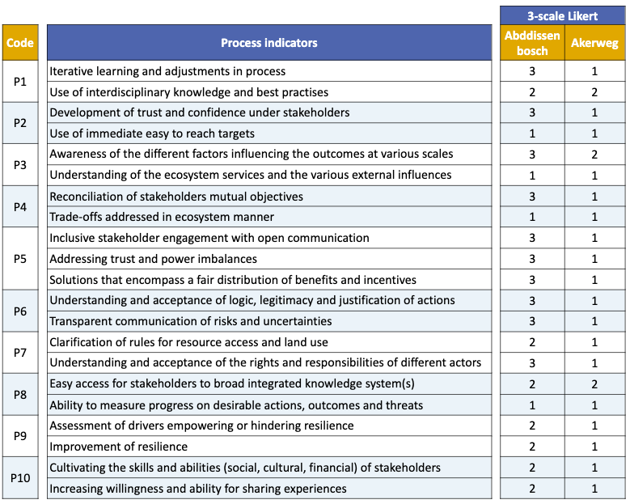

Supplementary File 4 illustrates the list of actors interviewed.

 | Actors |  | Date interview | Case
Profit | 1 | NPG Energy, former project developer | 19 July 2021 | Adbissenbosch
Politics | 2 | Municipality of Landgraaf, Sustainability Coordinator | 20 July 2021 | Adbissenbosch & Akerweg
 | 3 | Municipality of Landgraaf, Alderman | 20 July 2021 | Adbissenbosch & Akerweg
People | 4 | Resident of Ubach over Worm | 21 July 2021 | Akerweg
 | 5 | Resident of Abdissenbosch | 21 July 2021 | Abdissenbosch
 | 6 | Resident of Ubach over Worm | 21 July 2021 | Akerweg
Planet | 7 | IKL, landscape designer | 22 July 2021 | Abdissenbosch
Profit | 8 | Kronos Solar, manager | 22 July 2021 | Akerweg
Politics | 9 | Province Limburg, projectmanager | 26 July 2021 | Abdissenbosch
Planet | 10 | Bodemzorg Limburg, projectmanager | 27 July 2021 | Abdissenbosch
Profit
 | 11 | Unisun Energy, CEO | 28 July 2021 | Akerweg
Planet | 12 | Natuur en Milieufederatie Limburg, employee | 28 July 2021 | Adbissenbosch
 | 13 | Natuur en Milieufederatie Limburg, employee | 28 July 2021 | Akerweg
People | 14 | Chairman advisory group | 29 July 2021 | Abdissenbosch & Akerweg
Politics | 15 | Municipality of Landgraaf, Alderman | 5 August 2021 | Abdissenbosch & Akerweg

