SUPPLEMENTARY
- Formulas
This research uses OSMnx to measure the order of a neighborhood street network. OSMnx is a Python package developed by Boeing (2017, 2019) that offers various tools for calculating and presenting street network characteristics, including the entropy of neighborhood street orientations.
  - Shannon Entropy
$$H_{0}=- \sum_{i=1}^{n}{P(o_{i}}) \log_{e}P(o_{i})$$
where n is the total number of bins, indexes the bins, and P$o_{i}$ represents the proportion of orientations that fall in the ith bin.
where n is the total number of bins, indexes the bins, and P represents the proportion of orientations that fall in the i^{th} bin.
  - Normalized Entropy
where equals 3.584 nats. equals 1.386 nats (Boeing 2019)
  - Betweenness Centrality
C^{B} is betweenness.
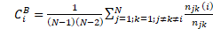 $C_{i}^{B}=\frac{1}{\left(N-1\right)\left(N-2\right)}\sum_{j=1;k=1;j≠k≠i}^{N}{\frac{n_{jk} \left(i\right)}{n_{jk}}}$
where is the number of shortest routes between nodes j and k, and is the number of these shortest paths that overpass node i.
- Table
Table 1: Mean values of betweenness and normalized entropies of one-square-mile samples of sixty world’s urban areas.
City | $$H_{o}$$ | φ | B | $$\log_{2}B$$ | Block size (m)
West Island | 2.74 | 0.62 | 7,193 | 12.81 | 58.3
Bani Yas | 2.51 | 0.74 | 2,010 | 10.97 | 82.9
Al Bahya East | 2.27 | 0.82 | 1,499 | 10.55 | 88.4
MBZ | 2.3 | 0.83 | 1,323 | 10.37 | 101.1
Khalifa | 2.19 | 0.86 | 838 | 9.71 | 108.6
Falah | 2.17 | 0.84 | 750 | 9.55 | 136.5
Al Bahya West | 1.66 | 0.98 | 118 | 6.88 | 192.8
Bangkok | 2.86 | 0.55 | 6,245 | 12.61 | 57.6
Beijing | 2.18 | 0.87 | 1,038 | 10.02 | 110
Chandigarh | 2.46 | 0.76 | 2,785 | 11.44 | 79.5
Hanoi | 2.7 | 0.64 | 3,492 | 11.77 | 67.2
Hongkong | 2.75 | 0.61 | 7,853 | 12.94 | 51.1
Melbourne | 2.63 | 0.68 | 7,567 | 12.89 | 50.6
New Delhi | 2.57 | 0.71 | 2,281 | 11.16 | 86
Pyongyang | 2.5 | 0.71 | 3,066 | 11.58 | 85.4
Seoul | 2.79 | 0.59 | 3,352 | 11.71 | 64.4
Shanghai | 2.68 | 0.65 | 4,047 | 11.98 | 92.2
Singapore | 2.79 | 0.59 | 8,097 | 12.98 | 51
Sydney | 2.76 | 0.61 | 9,246 | 13.17 | 46.3
Taipei | 2.76 | 0.61 | 6,376 | 12.64 | 71.4
Tokyo | 2.89 | 0.53 | 29860 | 14.87 | 33.1
Barcelona | 2.71 | 0.64 | 10,770 | 13.39 | 41.5
Berlin | 2.84 | 0.56 | 10,660 | 13.38 | 40.8
Budapest | 2.58 | 0.7 | 3,338 | 11.7 | 61.9
Kiev | 2.84 | 0.56 | 16,398 | 14 | 40.8
London | 2.79 | 0.59 | 16,794 | 14.04 | 37.7
Madrid | 2.81 | 0.58 | 10,406 | 13.35 | 47.3
Moscow | 2.84 | 0.56 | 21,307 | 14.38 | 43.2
Paris | 2.75 | 0.61 | 7,174 | 12.81 | 50.3
Prague | 2.89 | 0.53 | 14,650 | 13.84 | 40.9
Rome | 2.79 | 0.59 | 6,301 | 12.62 | 53.4
Vienna | 2.9 | 0.53 | 14,153 | 13.79 | 38.7
Bogota | 2.68 | 0.65 | 3,998 | 11.97 | 69.1
Brasilia | 2.49 | 0.75 | 4,783 | 12.22 | 65.1
Buenos Aires | 2.44 | 0.76 | 2,967 | 11.53 | 66.5
Caracas | 2.54 | 0.72 | 1,022 | 10 | 116.3
Havana | 2.62 | 0.68 | 2,730 | 11.41 | 68.9
Mexico City | 2.52 | 0.72 | 1,766 | 10.79 | 88.5
Rio de Janeiro | 2.74 | 0.62 | 2,439 | 11.25 | 77
Sao Paulo | 2.61 | 0.69 | 1,652 | 10.69 | 82.1
Baghdad | 2.45 | 0.76 | 1,143 | 10.16 | 118
Beirut | 2.74 | 0.62 | 7,805 | 12.93 | 52.8
Cairo | 2.78 | 0.6 | 19,309 | 14.24 | 40.7
Casablanca | 2.74 | 0.62 | 5,549 | 12.44 | 56.6
Damascus | 2.75 | 0.61 | 2,865 | 11.48 | 74
Dubai | 2.68 | 0.65 | 3,472 | 11.76 | 70.5
Istanbul | 2.79 | 0.59 | 7,592 | 12.89 | 52.6
Jerusalem | 2.73 | 0.63 | 8,213 | 13 | 54.9
Johannesburg | 2.59 | 0.7 | 1,320 | 10.37 | 95.3
Lagos | 2.56 | 0.71 | 1,974 | 10.95 | 94.7
Mogadishu | 2.65 | 0.66 | 4,876 | 12.25 | 58.9
Tehran | 2.76 | 0.61 | 11,748 | 13.52 | 52.8
Boston | 2.84 | 0.56 | 9,457 | 13.21 | 49.4
Chicago | 2.73 | 0.62 | 10,157 | 13.31 | 47.1
Honolulu | 2.66 | 0.66 | 3,329 | 11.7 | 76.5
Houston | 2.65 | 0.67 | 9,245 | 13.17 | 43.8
Las Vegas | 2.66 | 0.66 | 7,508 | 12.87 | 56.6
Los Angeles | 2.64 | 0.67 | 4,253 | 12.05 | 69.2
Manhattan | 2.58 | 0.69 | 5,895 | 12.53 | 53
Miami | 2.48 | 0.75 | 2,849 | 11.48 | 67.6
Phoenix | 2.44 | 0.76 | 3,315 | 11.69 | 87.8
Portland | 2.75 | 0.61 | 14,345 | 13.81 | 43.5
San Francisco | 2.6 | 0.69 | 11,206 | 13.45 | 45.5
Seattle | 2.72 | 0.63 | 17,132 | 14.06 | 39
Toronto | 2.59 | 0.7 | 15,253 | 13.9 | 54
Vancouver | 2.7 | 0.64 | 6,604 | 12.69 | 51.7
Washington | 2.64 | 0.66 | 12,034 | 13.55 | 47.1

- Figures
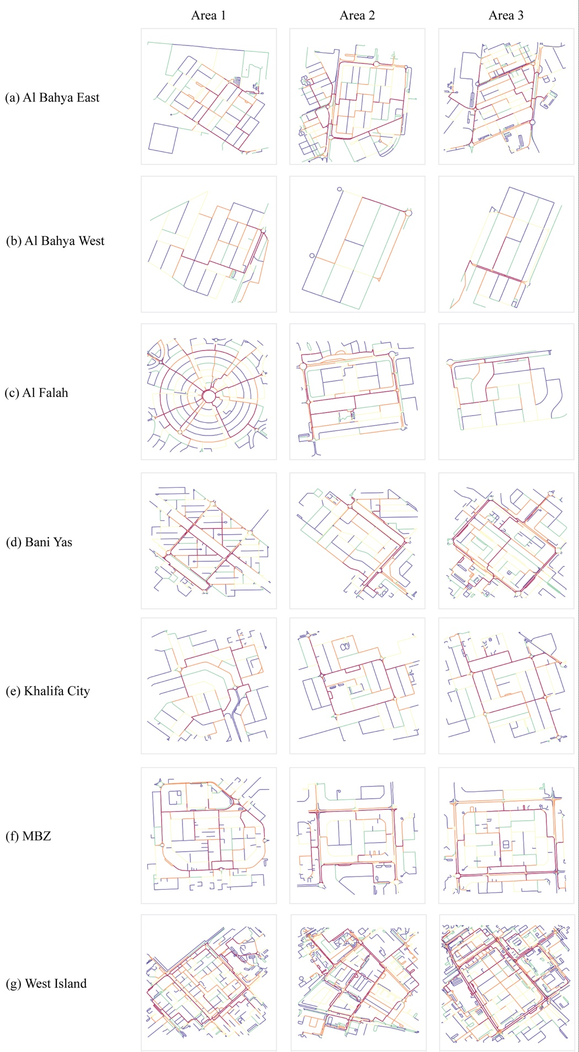
Figure 3.1: Betweenness maps of selected samples in Abu Dhabi.
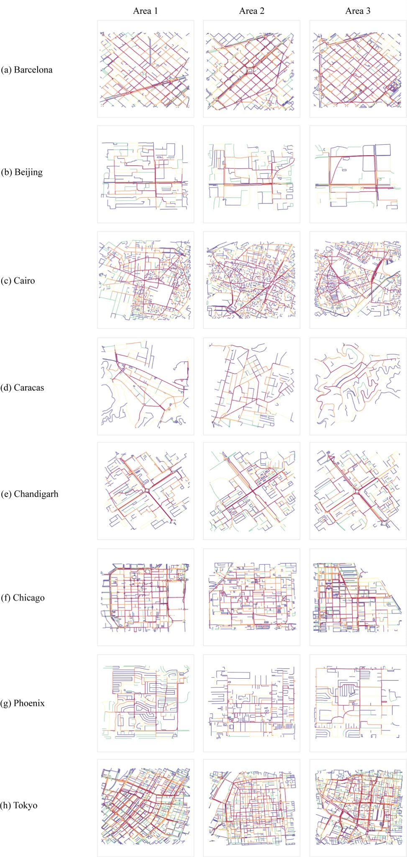
Figure 3.2: Betweenness maps of eight selected samples of world’s cities.

REFERENCES
Boeing, G. (2017). OSMnx: A Python package to work with graph-theoretic OpenStreetMap street networks. The Journal of Open Source Software, 2(12), 215.
Shannon, C.E., 1948. A mathematical theory of communication. The Bell System Technical
Journal 27, 379–423, p. 623–656.

