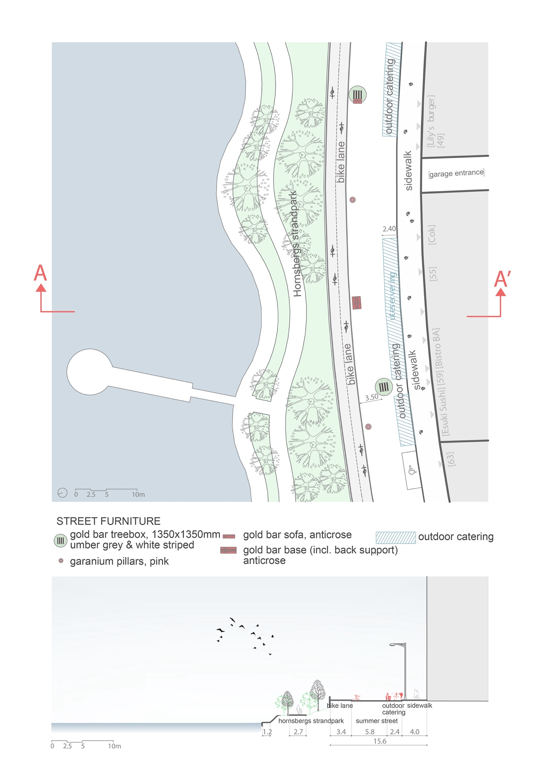
Appendix 1. The design of the Summer Street HBS, east section, by author.

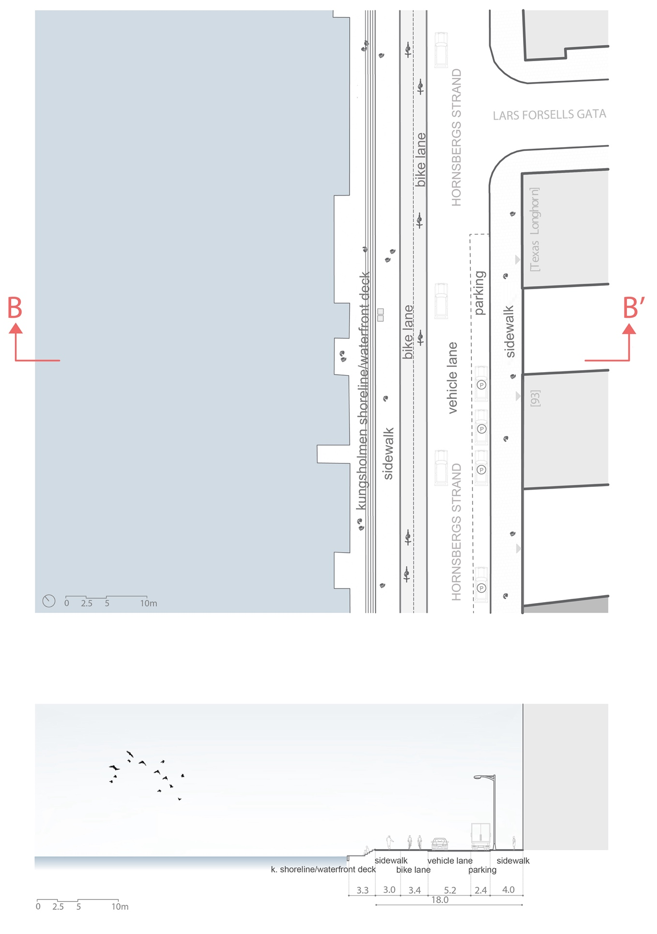
Appendix 2. The design of the Street HBS, west section, by author.

