Figures 6a-b: Westhafen and Deutschherrnufer (Sources: Urbanquest, Mylius)
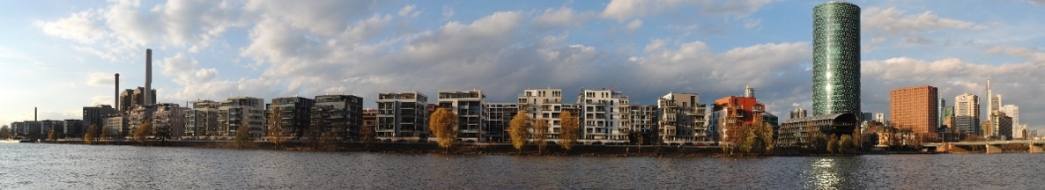

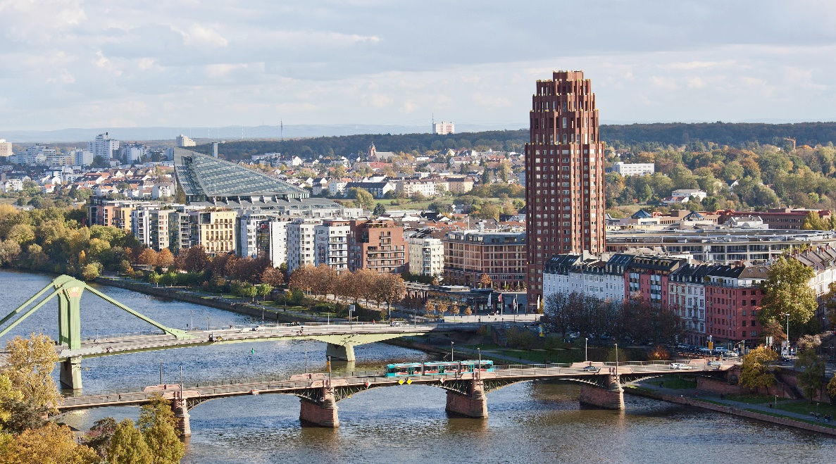

Figures 7a-b: New high-rise residential pioneers: Theresienhöhe, Falkenried (Sources: Maximilian Dörrbecker, author)
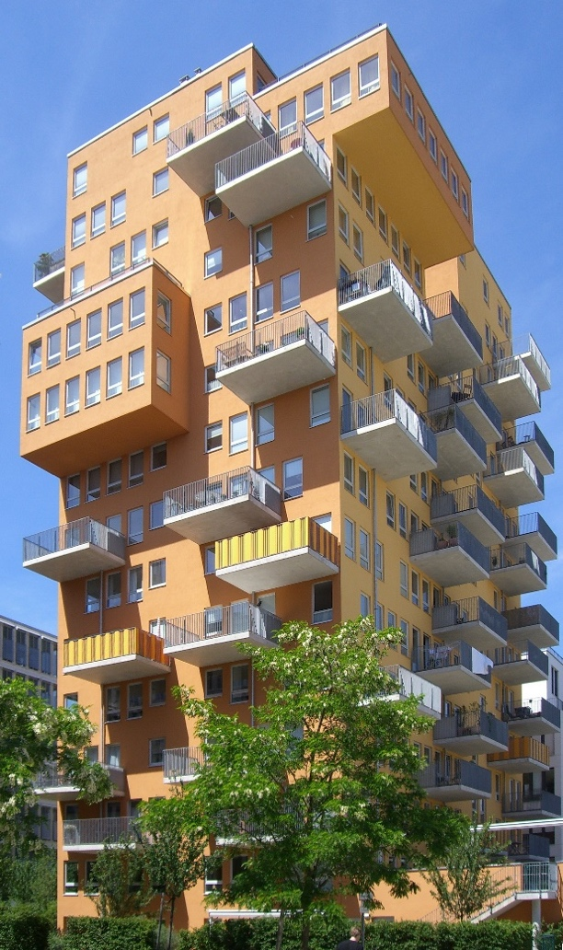

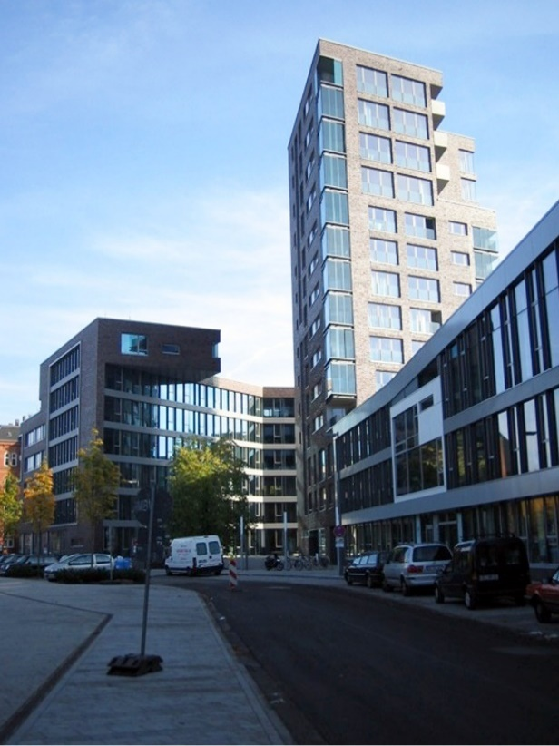

Figures 8a-e: Bavaria-Quartier, Upside Berlin, view of Europaviertel and its “Skyline Plaza” including Grand Tower, and Omniturm (Sources: Thorsten Bätge, author, Epizentrum, Sebastian Kasten, Fabian Thiel)
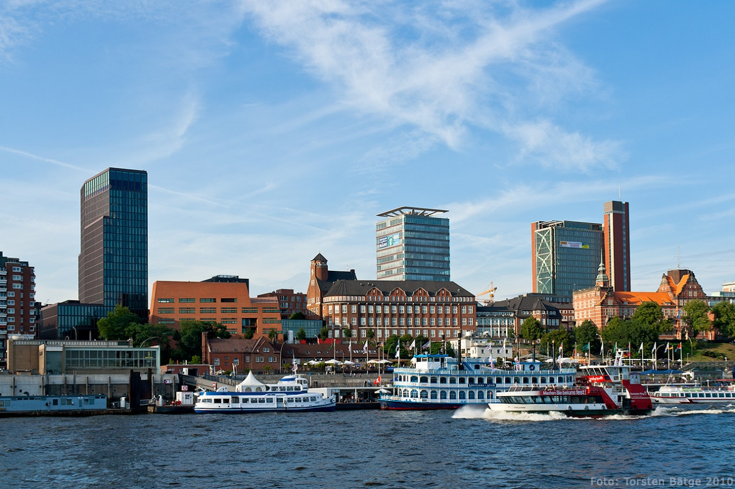

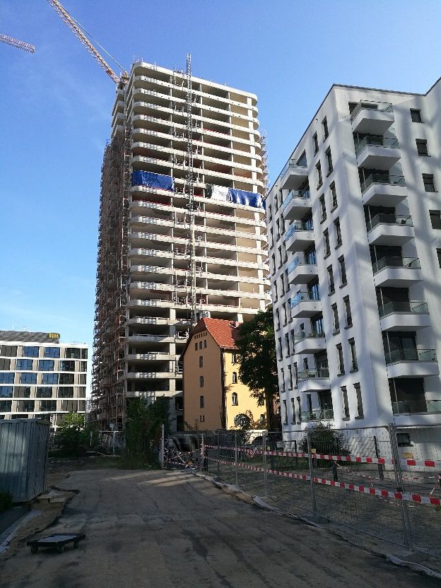

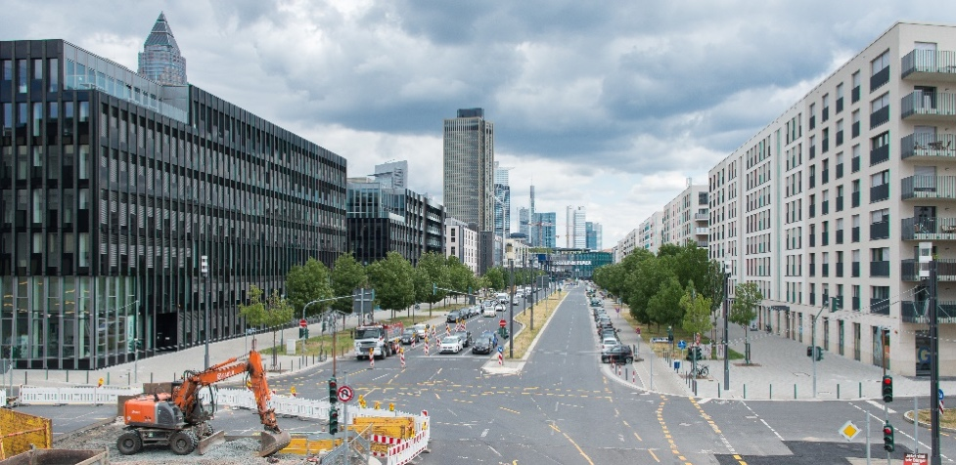

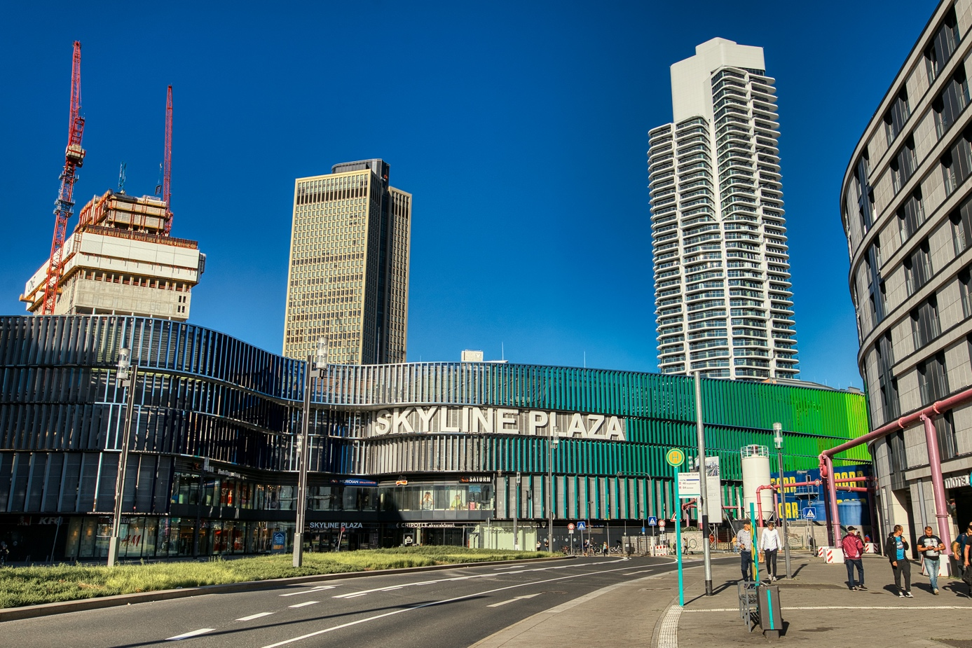

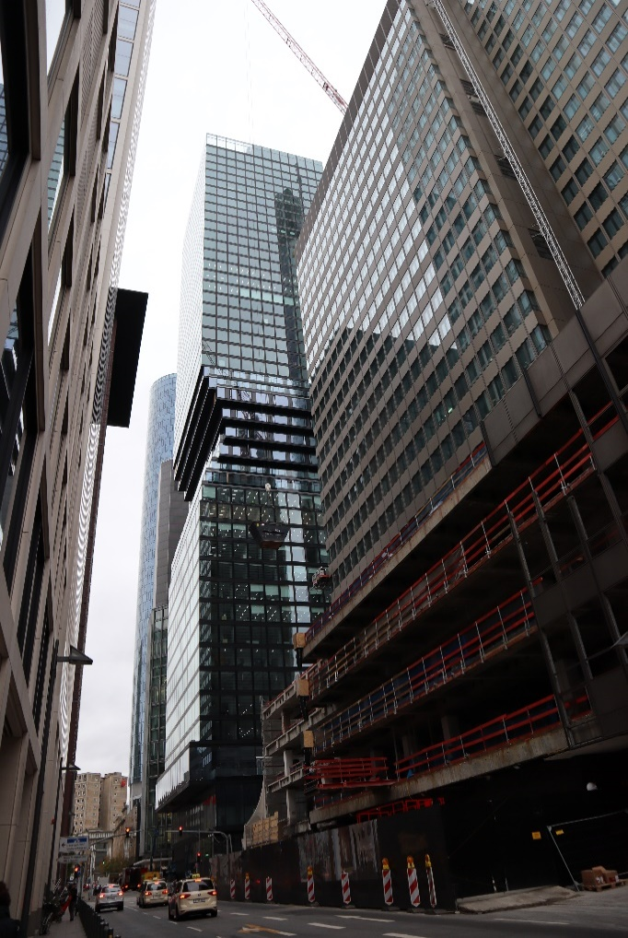

Figure 9a-c: Lyoner Straße 19, old and new Henninger Turm building (Sources: Jean-Luc Valentin, Dontworry)
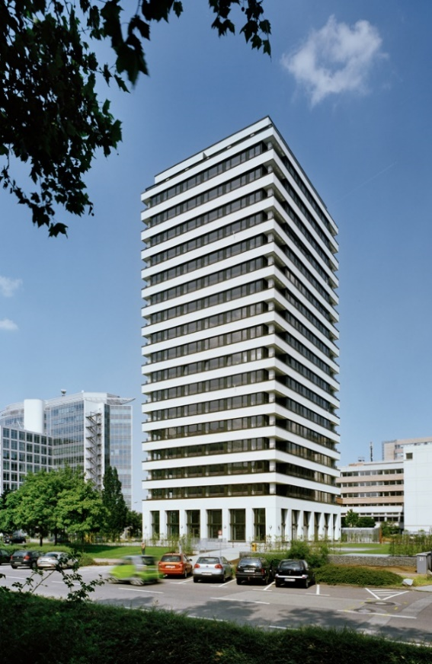

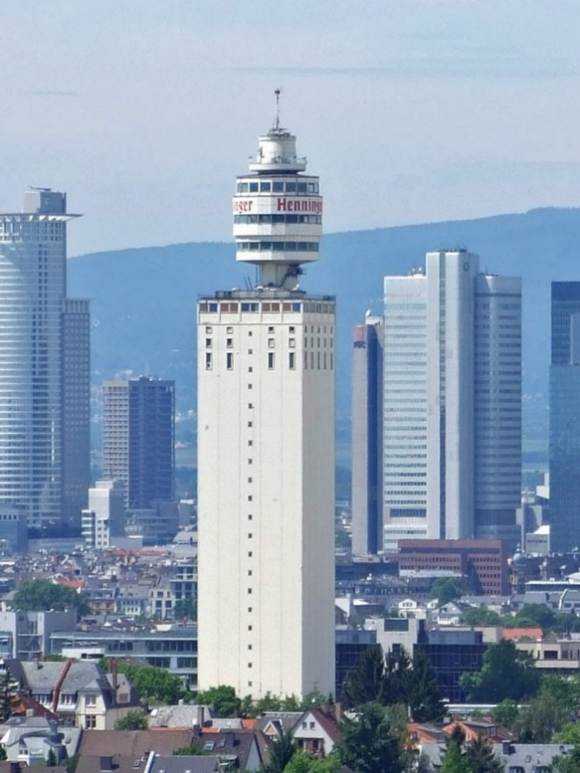

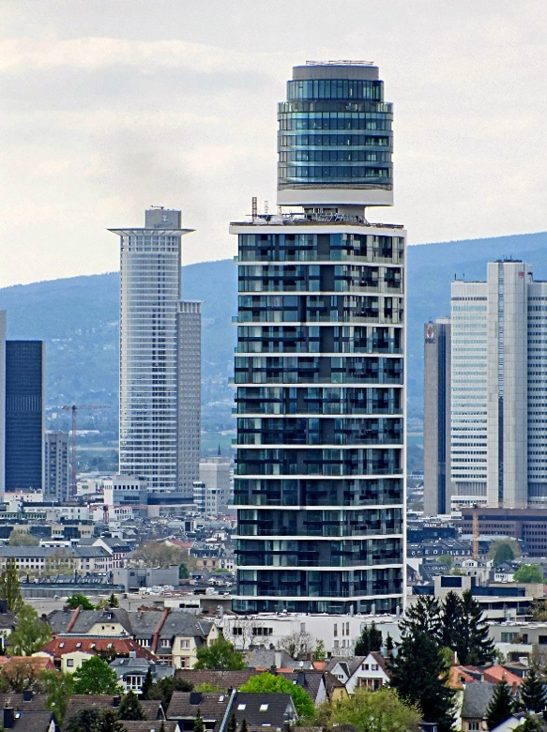

Figure 10: New building by Howoge company in Berlin at Stefan-Heym-Platz designed by Baumschlager Eberle, completed 2021 (Author)
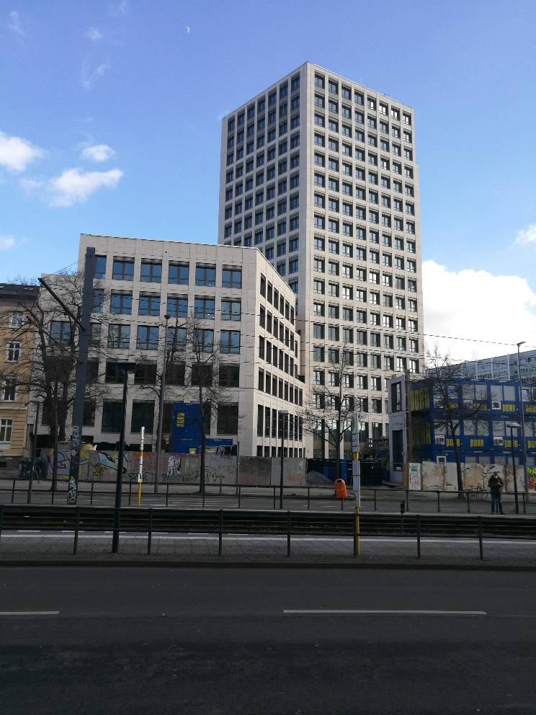

Figure 11: Living Levels (Source: Joachim Kohler)
